Reflow oven 1.0  
Simulation

Toggling protection

Schematic:

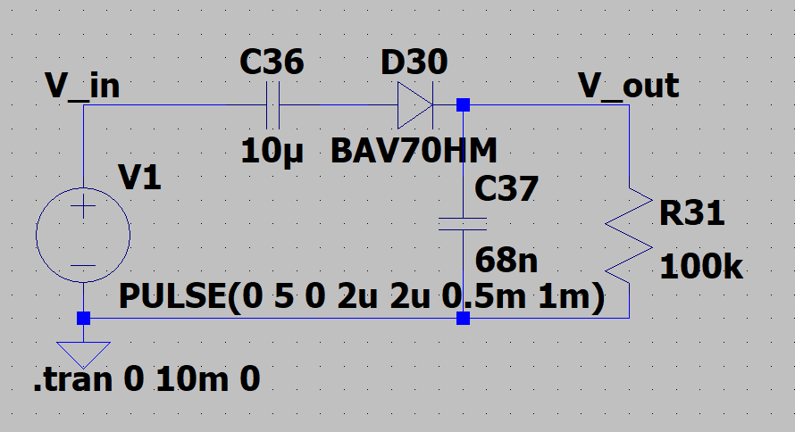

Simulation resuluts:

Normal operation (1 kHz square wave)

* Green trace: Vin
* Blue trace: Vout



Constant 5V

* Green trace: Vin
* Blue trace: Vout



Constant 0V

* Green trace: Vin
* Blue trace: Vout

